Year 12 Chemistry Topic Test # 2 (Bonding) - 2012

Name: __________________________________ Mark = _____ / 44

Part 1: Multiple Choice Section 10 marks
_____________________________________________________________________________

1. Two flasks contain pure substances. In each flask, only dispersion forces exist between
molecules. The substances in the two flasks could be:

A. CH₄ and H₂S
B. NH₃ and F₂
C. SiH₄ and H₂O
D. CH₄ and F₂

2. Diamond is an electrical insulator because:

A. It is a crystalline substance.
B. All the valence electrons are delocalised.
C. All the valence electrons are involved in single covalent bonds.
D. It consists only of non-conducting carbon atoms.

3. Which of the following have hydrogen bonding between their molecules?

I CH₃F
II CH₃NH₂
III CH₃OH
IV CS₂

A. II and III only
B. III and IV only
C. I and III only
D. I, II and III only

4. Water exists as discrete H₂O molecules with the two hydrogen atoms each covalently bonded
to oxygen. Below 0°C, at atmospheric pressure, water exists as a crystalline solid, ice, in
which the individual H₂O molecules are held in an open network lattice. The bonding that
holds the water molecules together in the ice lattice is best described as being due to:

A. dispersion forces only
B. dispersion forces plus hydrogen bonding
C. ionic bonding
D. ionic bonding plus hydrogen bonding
5. Consider the following set of successive ionisation energies (MJ mol⁻¹):

0.74 1.45 7.73 10.54 13.63

Which of the following elements is most likely to have such a set of ionisation energies?

A. C
B. K
C. Mg
D. O

6. Which one of the following compounds has a net dipole?

A. CBr₄
B. CH₃Br
C. C₂Br₆
D. Br₂C=CBr₂

7. The molar heat of sublimation (the heat required to convert 1 mol of solid directly to the
gas state) of solid helium is 0.015 kJ mol⁻¹ whereas that of ice is 46.9 kJ mol⁻¹.

Which of the following statements help to explain these facts?

I Only dispersion forces are present between helium atoms.
II There is strong hydrogen bonding between water molecules in ice.
III There are strong covalent bonds within water molecules in ice.
IV There are weak covalent bonds between helium atoms.

A. I and II only.
B. I, II and III only.
C. I, II and IV only.
D. II, III and IV only.

8. Which of the following equations correctly represents the second ionisation energy of the
element aluminium?

A. A⁺(s) → A ²⁺(g) + e⁻
B. A(g) → A³⁺(g) + 3 e⁻
C. A⁺(g) → A ²⁺(g) + e⁻
D. A²⁺(g) → A³⁺(g) + e⁻

9. The molecule N₂C₄ has the number X non-bonding pairs of electrons, number Y of polar bonds and the number Z bonding pairs of electrons. What are the values of X, Y and Z?

 | X | Y | Z
A. | 15 | 5 | 4
B. | 14 | 4 | 5
C. | 15 | 5 | 5
D | 14 | 4 | 4

10. Which of the following statements about dispersion forces in a series of molecules is
correct?

A. An increased molecular weight leads to greater mass of the molecule and hence
stronger dispersion forces.
B. An increased number of protons and electrons lead to stronger dispersion forces.
C. Larger electronegativity differences lead to stronger dispersion forces.
D. The presence of an atom such as O or N bonded to H leads to stronger dispersion
forces.

End of Part 1

Part 2: Short Answer Section 34 marks
_____________________________________________________________________________

1. Nitrogen (N₂) exists is a gas at room temperature. Nitrogen trichloride (NC₃) exists as a
liquid at room temperature.

(a) Name the bonding that would exist in a container of each substance giving
reasons for your answer.

N₂ _______________________________________________________________

_______________________________________________________________

_______________________________________________________________

_______________________________________________________________

_______________________________________________________________

_______________________________________________________________

NC₃ _______________________________________________________________

_______________________________________________________________

_______________________________________________________________

_______________________________________________________________

_______________________________________________________________

_______________________________________________________________

(5 marks)

;
2. Complete the following table:

Species | Electron dot diagram | Name of shape | Polarity  (polar or non-polar)
SO₂
HCN
SO₄²⁻ |  |  | N/A
PI₃

(11 marks)

3. The following table gives some information about three elements in the fourth row of the
Periodic Table.

Element | Electrical conductivity  (MS m^{–1}) | First ionisation energy  (kJ mol⁻') | Melting point  (°C)
Potassium | 14 | 425 | 63
Calcium | 29 | 596 | 650
Germanium | 1 x 10⁻⁴ | 762 | 938

(a) What type of bonding would you expect to occur in germanium?

____________________________________________________________________
(1 mark)
(b) Justify your answer.

____________________________________________________________________

____________________________________________________________________

____________________________________________________________________

____________________________________________________________________

____________________________________________________________________
(3 marks)
(c) Explain the trend in ionisation energies of the elements above.

____________________________________________________________________

____________________________________________________________________

____________________________________________________________________

____________________________________________________________________

____________________________________________________________________
(1 mark)

(d) Would the value of potassium’s second ionisation energy be larger or smaller than
that for calcium? Explain why.

____________________________________________________________________

____________________________________________________________________

____________________________________________________________________

____________________________________________________________________

____________________________________________________________________
(2 marks)

4. Use your understanding of atomic structure and bonding to:

(a) Complete a sketch showing the boiling points of the hydrides of group 14 (———)
and group 17 (- - - - -) on the following graph.

2
3
4
5
Melting
Point

Period Number

(4 marks)

(b) Explain the overall trend shown on the graph:

____________________________________________________________________

____________________________________________________________________

____________________________________________________________________

____________________________________________________________________

____________________________________________________________________
(2 marks)

(c) Give reasons for any exceptions to this trend.

____________________________________________________________________

____________________________________________________________________

____________________________________________________________________

____________________________________________________________________

____________________________________________________________________
(1 mark)

5. Using your knowledge of atomic structure and bonding explain the following physical data:

Substance | Solubility in water at 25°C (g L⁻¹)
1-pentanol  (CH₃CH₂CH₂CH₂CH₂OH) | 22.0
1-hexanol  (CH₃CH₂CH₂CH₂CH₂CH₂OH) | 5.9

__________________________________________________________________________

__________________________________________________________________________

__________________________________________________________________________

__________________________________________________________________________

__________________________________________________________________________

__________________________________________________________________________

__________________________________________________________________________

__________________________________________________________________________

__________________________________________________________________________

__________________________________________________________________________

__________________________________________________________________________

__________________________________________________________________________

__________________________________________________________________________

__________________________________________________________________________

__________________________________________________________________________

__________________________________________________________________________

__________________________________________________________________________
(4 marks)

End of Test

SVACS

Year 12 Chemistry Topic Test # 2 (Bonding) - 2012

Name: ANSWERS

Part 1: Multiple Choice Section 10 marks
_____________________________________________________________________________

1. D 2. C 3. A 4. B 5. C 6. B 7. A 8. C 9. B 10. B each

Part 2: Short Answer Section 34 marks
_____________________________________________________________________________

1. Nitrogen (N₂) exists is a gas at room temperature. Nitrogen trichloride (NC₃) exists as a
liquid at room temperature.

(a) Name the bonding that would exist in a container of each substance giving
reasons for your answer.

N₂ N-N bonds are covalent

Intermolecular bonding is dispersion forces only as N₂ molecules
are non-polar
NC₃ N-C bonds are covalent

Intermolecular bonding is dipole-dipole and dispersion forces
– dipole-dipole because molecule is polar
− dispersion forces because they occur between all particles
(5 marks)

2. Complete the following table:

Species | Electron dot diagram | Name of shape | Polarity  (polar or non-polar)
SO₂ | 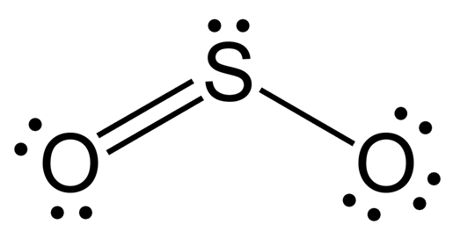 | bent | polar
HCN |  | linear | polar
SO₄²⁻ | 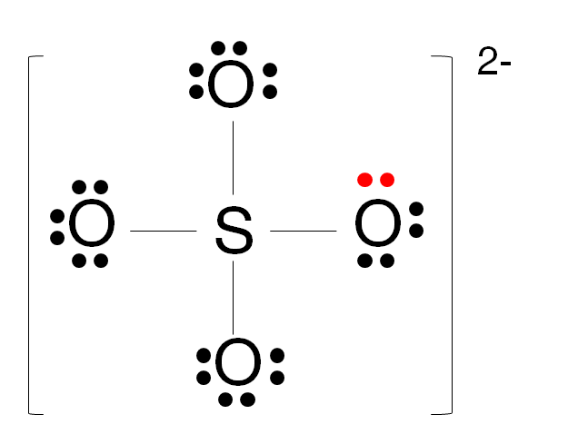 | tetrahedral | N/A
PI₃ | 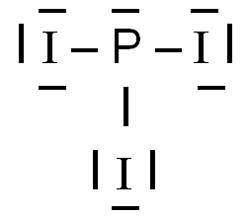 | pyramidal | polar

(11 marks)

3. The following table gives some information about three elements in the fourth row of the
Periodic Table.

Element | Electrical conductivity  (MS m^{–1}) | First ionisation energy  (kJ mol⁻') | Melting point  (°C)
Potassium | 14 | 425 | 63
Calcium | 29 | 596 | 650
Germanium | 1 x 10⁻⁴ | 762 | 938

(a) What type of bonding would you expect to occur in germanium?

covalent network
(1 mark)
(b) Justify your answer.

Poor electrical conductor, so can’t be metallic

High melting point, so can’t be molecular

Obviously not ionic, so ∴ covalent network
(3 marks)

(c) Explain the trend in ionisation energies of the elements above.

Increasing nuclear charge (from K to Ca to Ge), with a similar degree of
shielding

∴ more energy required to remove e⁻ from Ge than Ca than K.
(1 mark)

(d) Would the value of potassium’s second ionisation energy be larger or smaller than
that for calcium? Explain why.

Larger

The removal of 2nd e⁻ from Ca is from the same (fourth) shell,
whereas K is from the third shell – less shielding, ∴ more strongly
attracted and more energy required

(2 marks)

4. Use your understanding of atomic structure and bonding to:

(a) Complete a sketch showing the boiling points of the hydrides of group 14 (———)
and group 17 (- - - - -) on the following graph.

2
3
4
5
Melting
Point

Period Number

mp of group 14 hydrides increasing
mp of group 17 hydrides higher than group 14
mp of group 17 hydrides increasing from period 3 to period 5
mp of group 17 hydride in period 2 (HF) higher than period 3
(4 marks)

(b) Explain the overall trend shown on the graph:

Increasing mp with increasing size of molecules

This is due to increasing strength of dispersion forces with increasing
size of molecule, as temporary dipoles become larger
(2 marks)

(c) Give reasons for any exceptions to this trend.

HF has a particularly strong form of dipole-dipole attraction, called
hydrogen bonding.

This arises due to the great difference in electronegativity between
H and F and the small size of F.
(1 mark)

5. Using your knowledge of atomic structure and bonding explain the following physical data:

Substance | Solubility in water at 25°C (g L⁻¹)
1-pentanol  (CH₃CH₂CH₂CH₂CH₂OH) | 22.0
1-hexanol  (CH₃CH₂CH₂CH₂CH₂CH₂OH) | 5.9

Water is polar molecule and contains with dispersion forces and hydrogen
bonding between molecules.

Hydrogen bonding also exists between molecules of each alcohol, but
dispersion forces become more significant as the molecule becomes
larger (as the carbon chain increases in length).

Only dispersion forces form between the carbon chain and water, which
are much weaker than hydrogen bonds between water and dispersion
forces between alcohols.

As the alcohol size increases, solubility in water decreases.

(4 marks)

End of Test

